*Dear Parents, Staff, Governors & Children*

|  |  |  |
| --- | --- | --- |
| ***Red Class*** | ***Yellow Class*** | http://www.pinxtonkirkstead.derbyshire.sch.uk/sites/default/files/attendance%20trophy.png***Blue Class*** |
| *75.46%* | *95.65%* | *95.86%* |

Last week’s whole school attendance = 88.99%. Well done to Blue Class who will be rewarded with the Attendance (treat filled) Trophy.

***DAILY: 8.00am: Breakfast Club***

***9.00am: Registration: Classroom***

***Daily: Collective Worship & Assembly***

WEEK 2 OF NEW CHARTWELLS DINNER MENU

Mon 15th: am: SATs KS1: English reading

11.45: Open the Book assembly

pm: Verena Watkiss: music lessons & Red Class group ukulele lessons

3.30-4.15pm: Ukulele Club: Yellow/Blue Class

Tues 16th: 9.15am: Light & Life assembly

am: SATs KS1: English reading

3.30-4.30pm: Cookery Club (4 of 4)

**17th -19th: School Camp Porthpean Outdoor Educ Centre**

Weds 17th: 10.00am: Bob (& Ki or Rosie) Pets As Therapy

am: SATs KS1: Maths arithmetic

Thurs 18th: am: SATs KS1: Maths reasoning

pm: No Drum Lessons this week

3.30-4.30pm: Zumba Club (4 of 5)

Frid 19th: pm: Red Class Swimming Lesson 4 of 10

12.30-1pm: Glee Club (singing): all years

3.30-4.15pm: Guitar Club

**Forthcoming diary dates:**

23rd: HCC Transition: Taster Maths Course

24th: Oll an Gwealla male voice choir

25th: 11.30am: Church Service: Ascension

29-2/6 HALF TERM BREAK

5th June: Summer term resumes

Ms Froehlich, Swiss teacher, teaching experience

7th: 2.00pm: P& F Meeting

9th: Mr Dudley & 2 HCC students meeting Year 6s

12th: 2.00pm: Breage School Dance

13th: HCC transition: taster English class

19th & 20th: Year 6s, Helston C College transition days

24th: Breage School Summer Fair

28th: P & F Meeting (inc Finance)

3rd July: Parent Meetings

5th: Sports Day?

6th: Leavers’ Service

7th: Leavers’ Disco

12th: Joseph performance: dress rehearsal

13th & 14th: Joseph performance

21st: Last day of Summer Term

**Cookery Club – today (4 of 4)**

Holly T, Clemmie, Dalton & Bradley W will be making chocolate chip muffins tomorrow!

**Red Class Swimming Lessons: 4 of 10 - Friday**

MC900446290[1]Red Class did really well last Friday. They learnt how to float and all children had go. All children need: swimming costume & towel (goggles are optional but a swim hat is required to be worn if your child has long hair). We do have a small stock of swim hats if needed.

**PE Kit**

Please can we ask that all children have PE kit in school each school day? There are many children without kit in school. PE kit consists of navy shorts and a white t-shirt with plimsolls or trainers.

**School Uniform**

Many random colours are creeping into school uniform. School uniform should consist of a navy sweatshirt, cardigan or hoody, white polo shirt or collared shirt, black or grey trousers or pinafore/skirt (grey, white or black tights/socks). Girls can wear royal blue small chequered summer dresses with a navy sweatshirt or cardigan (if they feel it’s warm enough!). The school office holds a small stock of the basics – additional items may need to be to be ordered (please allow ten working days for delivery).

**Lost Sweatshirt – Ewan – Blue Class**

Please could everyone check their school jumpers as Ewan’s has gone astray – it is clearly marked with his name inside. Thank you.

**Wraparound Child Care – starting after May half term**

Go Active is OFSTED registered and will be running the wraparound child-care here after school. Please return completed forms as soon as possible. Timings can be flexible eg. if you only require care until 5pm charges will be adjusted accordingly. If you require more forms (one per child is required to be completed), please ask the school office for additional copies. ***We have only received back a few forms but expected a lot more from the feedback provided. Without adequate uptake, wraparound child care is unlikely to run.***

**Cornish Singing Schools Scheme**

On Wednesday 24th May we are delighted to have arranged for Oll an Gwella male voice choir to come into school to work with the children. The choir will at first meet with the whole school and give a short performance. After this, each class will have a workshop with the choir learning a few songs. After lunch, there will be a short, impromptu concert with Blue, Yellow and Red Class participating and singing. After we will receive our Cornish Singing Schools Scheme Award.

**Special awards awarded last Friday**

Golden Awards were presented to: Bub, Teddy, Max & Riley (maths); Jacob (reading), Holly (maths). Well done to Carly who received a smiley face certificate having completed four sticker cards. The “star of the week” in Yellow Class was Ben and Red Class was Mia. Blue Class’ stars of the week were all of Year 6s for being SATs superstars!

[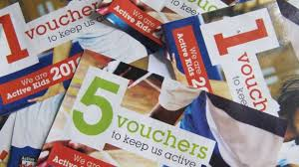](http://www.google.co.uk/url?sa=i&rct=j&q=j+sainsbury+active+kids+vouchers+image&source=images&cd=&cad=rja&docid=jK_wwL_1AW_D9M&tbnid=MeCTCdGzlK3m9M:&ved=&url=http://74thoakstreet.com/sainsburys-active-kids&ei=INf4Upm0LoKEhQefnYFo&bvm=bv.60983673,d.ZG4&psig=AFQjCNHxckF6jXXWDyLZyDJGFIXbpLNFUQ&ust=1392126113347394)**J Sainsbury – Active Kids Vouchers**

We are collecting J Sainsbury active kids vouchers. A collection box is just outside the school office. Thank you.

**100 Club Winners!**

Congratulations to this month’s 100 Club winners:

1st: Emma G (George’s mum)

2nd: Chloe J (Elijah, Harley & Phoenix)

3rd: Mrs Lloyd

**P&F Sweet Treat Friday**

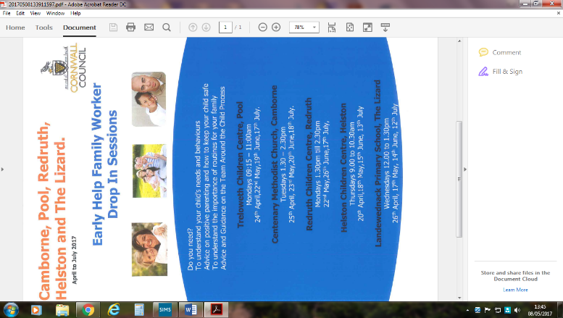Don’t forget your change on Fridays after school if you wish to buy a treat or two!

**Breage School Fair**

**Saturday 24th June – 12-4pm**

***Bric a brac*** – items needed for a stall – please send in anything suitable. Thank you.

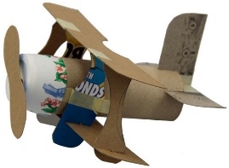***Recycled model competition*** – before the Easter break P&F sent home a flyer which briefly detailed this competition. If children could have a think about (if they haven’t already) what they would like to make and what they need to save from recycling to make it and collect it all ready to bring into school for the week beginning 19th April when they will be creating their model in class. Children will take their model home on Friday 23rd and can then bring it to the fair for judging on Saturday 24th.

***Breage Bake Off*** – Baking competition! Adult cake baking and children’s cupcake baking competition. Cakes/cupcakes will be judged at the start of the school fair with all entries then being sold to raise funds in the tea tent.

**Chartwells Special Menu – this Thursday – school census day**

Chartwells are putting on a special menu as follows. *Jacket potatoes also available but no packed lunches.*

Ham Pizza or

Cheese & Tomato Pizza

Full salad bar

Garlic & Herb Bread

Ice Cream or

Fresh Fruit

**Children’s University**

Passports available from the school office priced £2.50. Please could children bring their passports in to be updated each week by Mrs Brookes? There is lots of information on the school website under “Parent Info”. Thank you.